**MPCA: Banana Problem**

**Name:** Rithvik Rajesh Matta

**SRN:** PES2UG23CS485

**Sec:** H

1. Implement the Selection Sort algorithm in ARM Assembly language. The Selection Sort algorithm sorts an array by repeatedly finding the smallest element in the unsorted portion and swapping it with the element at the current position in the sorted portion. Input: An array of integers stored in memory. The size of the array, N, will be provided as part of the input. Output: The array will be sorted in ascending order. Constraints: The array contains integer values. The size of the array N is reasonably small (e.g., 5 to 10 elements).

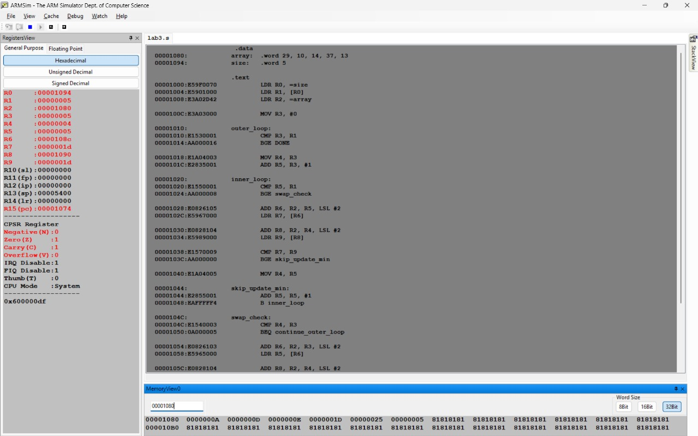

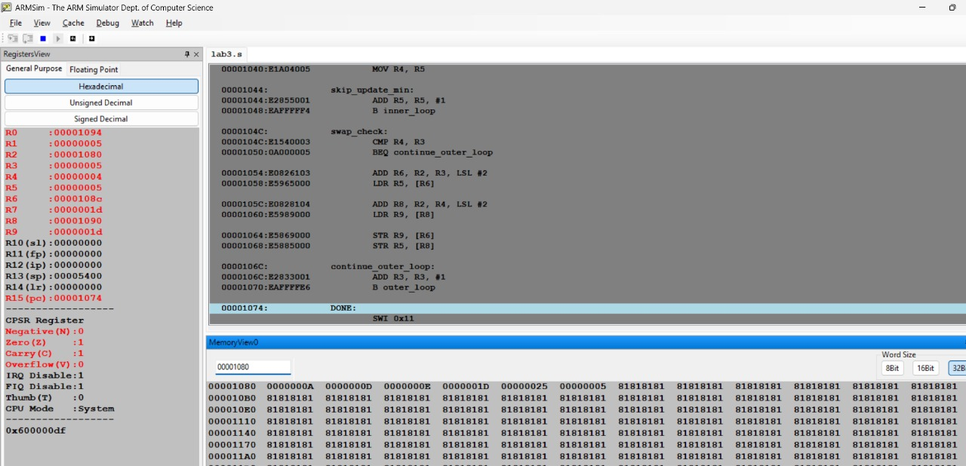

1. Write an ARM assembly program to evaluate a Prefix expression using stack. The program should support the basic arithmetic operations: addition (+), subtraction ( ).The operands will be single-digit integers (1-9). Input Format: The Prefix expression will be represented as an array of characters (i.e., a string). The expression should terminate with a null character ('\0'), indicating the end of the string. Output Format: The program will output the result of the Prefix evaluation.

